
Sreenidhi Institute of Science and Technology
Regulations:
A12
(An Autonomous Institution)
Code No: 3E709 Date:6-Dec-16(FN)
B. TECH. IV-Year I-Semester Examinations, Nov/Dec 2016 (Regular/Supple.)
SOFTWARE TESTING (Common to CSE and IT)

Time: 3 Hours Max. Marks: 70
Note: a) No additional answer sheets will be provided.
b) All sub-parts of a question must be answered at one place only, otherwise it will not be valued.
c) Assume any missing data

Part - A Max.Marks:20

Answer all QUESTIONS. EACH QUESTION CARRIES 2 MARKS.
1. Write any 3 Life cycle verification activities.
2. Distinguish Quality as “meeting requirements” and “fit to use”.
3. Write a formula for Backlog Management Index.
4. What are the categories in Tactical Risks?
5. What is a Histogram?
6. What is Cyclomatic Complexity?
7. Define Quality Control for software products.
8. Write any 4 types of software systems.
9. Define a Partial ordering relation.
10. What are the entities of CRUD Matrix?
Part – B Max.Marks:50
ANSWER ANY FIVE QUESTIONS. EACH QUESTION CARRIES 10 MARKS.

1. What is a Test Strategy? What are the Test factors involved in designing a Test Strategy?

2.(a) Explain various components of Quality Assurance.
(b) Illustrate the features of Capability Maturity Model.

3. Explain various Product Quality Metrics with suitable examples.

4. Explain the following:
(a) Verification Vs Validation
(b) Functional Vs Structural Testing.

5. Explain the following:
(a) Regression Testing
(b) Pareto Analysis

6. Apply the Partition algorithm for the following graph:
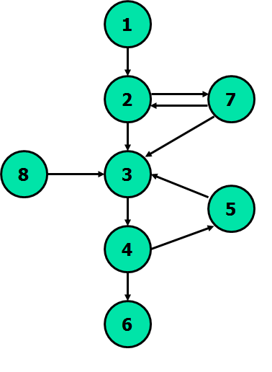
7 (a) Explain Economics of SDLC Testing.
(b) What is Quality Control and Auditing?

8 (a) What is the significance of a Power of a Matrix?
(b) What is a Decision Table? How does a Decision table is used to generate test cases?
-- 00 -- 00 --

